**Assignment 15.1 (multiple inheritance in Scala)**

Program to show multiple inheritance in scala.

Step1: Creating ‘trait’ called worker

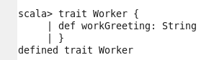

Step2: Creating class called Linguist

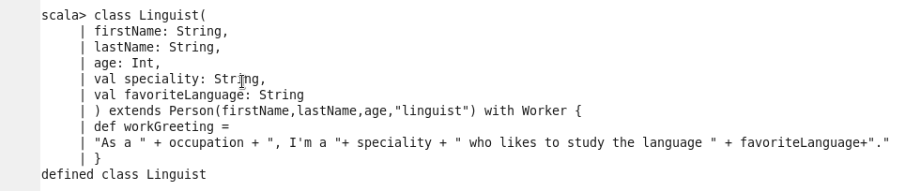

Step3: Creating class called Student

